Strategic Planning and Evidence Based Practices Training

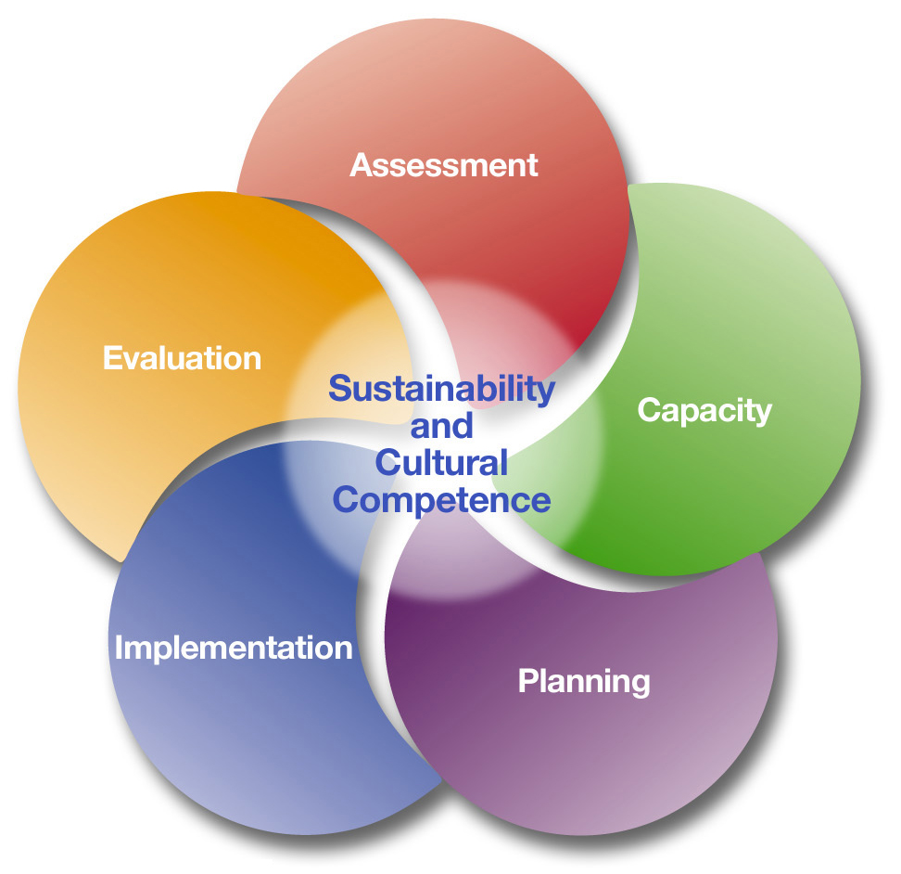

Funding for this training comes from the New Mexico Behavioral Health Services Division – Office of Substance Abuse Prevention (New Mexico Human Services Department). For questions, please contact: Karen Cheman, MPH (Staff Manager, NPN & SEOW Director), karen.cheman@state.nm.us, Office of Substance Abuse Prevention, BHSD/HSD, 37 Plaza La Prensa, Santa Fe, NM 87507, 505-476-9270.

Training Agenda and Objectives
Strategic Planning Timeline
Review of SPF steps
Introduction to Evidence Based Practices (EBPs)
Strategic Planning Components
Intervening Variables and Contributing Factors
Using SPF data for strategic planning
Prioritization Methods
SPF Findings
Review of EBPs to prevent UAD and Rx painkiller misuse
OSAP strategies to prevent UAD and Rx opioid misuse
Review of training information
Practice developing activities for strategies
Strategic Planning Tools: Logic Models and SMART document
Developing Community Logic Models
Writing SMART objectives
Activities: The core components of implementation
Developing a Comprehensive Strategic Plan (prioritize strategy sheet)

Objectives
- Carry out methods for prioritizing
- Justify strategy selection using assessment, capacity and readiness data
- Describe the various principles for defining “evidence based practice” for use in NM OSAP-supported substance abuse prevention
- Identify evidence based practices for prevention that fit the community
- Develop at least one goal and objective for your program using the OSAP list of approved strategies.
- Develop a strategic plan for prevention implementation

Strategic Prevention Framework
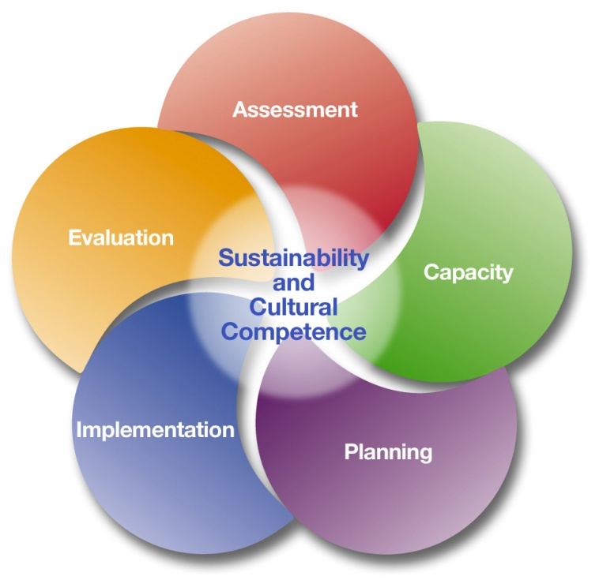

Assessing underage drinking and prescription painkiller misuse
Assessing substance use problems helps us understand the gravity and related behaviors in a community. Ask yourself?
- What substance use problems (for example, overdoses and alcohol poisoning) and related behaviors (for example, prescription drug misuse and underage drinking) are occurring in your community?
- How often are these problems and related behaviors occurring?
- Where are these substance use problems and related behaviors occurring (for example, at home or in vacant lots; in small groups or during big parties)?
- Who is experiencing more of these substance use issues and related behaviors? For example, are they males, females, youth, adults, or members of certain cultural groups?

Community Capacity Building and Coalition Development
Understanding local capacity, including resources and readiness for prevention, can help you:
- Make realistic decisions about which prevention needs your community is prepared to address
- Identify resources you are likely to need, but don’t currently have, to address identified prevention needs
- Assessing community readiness helps prevention professionals determine whether the time is right and whether there is social momentum towards addressing the issue or issues they hope to tackle.

Strategic Plan Components

Priority | The substance abuse issue in your community that is the highest or higher in importance to address through prevention efforts.
Logic Model | A tool for strategic planning that identifies the problems that the local prevention effort wishes to reduce. This tool also specifies strategies selected by the community that have been shown to change intervening variables and the measures to monitor changes in those variables.
Goal (Outcome) | The specific alcohol or opioid problem to be changed through the local environmental prevention effort, such as high risk drinking over the past 30 days, or a consequence of use such as alcohol-related traffic crashes.
Intervening Variable | Factors that have been identified to strongly influence the occurrence and magnitude of substance abuse and its related problems.
Indicator | Indicates the level or state of something. Provides information for decision-making, monitoring and evaluation.
Activity (Action Steps) | Purposeful and planned meetings, interventions, events and activities by the environmental prevention project to implement strategies (e.g. meeting with law enforcement, obtaining resources to conduct or increase local drinking and driving enforcement).
Strategy | A method or plan chosen to bring about a desired future, such as achievement of a goal or solution to a problem.

INTERVENING VARIABLES & CONTRIBUTING FACTORS
As the logic models indicate, there are multiple Intervening Variables (IVs) associated with your goals that will need to be addressed in your prevention efforts. IVs are the broad constructs/concepts such as Social and Retail Access. However, the specific issues in a community that explain the intervening variable are what we refer to as the contributing factors. These are identified through focus groups, surveys, observation and other data gathering processes. For example, contributing factors are the various parts of social access such as stealing alcohol from home, having family members purchase alcohol for underage youth, or stealing Rx drugs from grandparents. These all reflect social access but different aspects of it and each would require a different approach to address it effectively. Your needs assessment helped you identify the most important IVs, and by extension, the most relevant issues in your community.
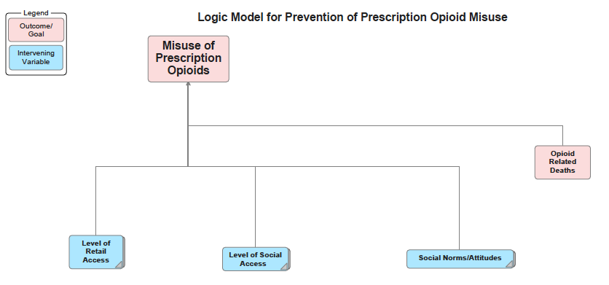
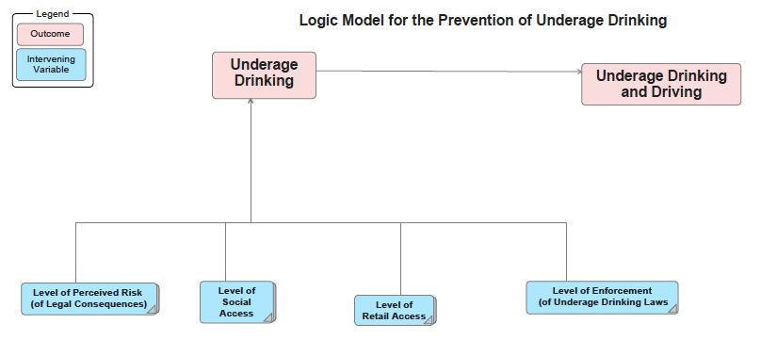
Identifying Intervening Variables, Contributing Factors, and Indicators

Consider what you learned during the Assessment and Capacity building phases

PRIORITY: Underage Drinking
In your community, what intervening variables are most important to address.
Check: | Intervening Variables: | Contributing Factors:
 | Social Access | - Friends & Relatives provide alcohol to minors  - Parties provide unsupervised access to alcohol
 | Retail Access | - Minors can purchase alcohol from local stores  - Rx pills are prescribed in large quantities
 | Low Enforcement | - Low resources to address UAD parties  - School policies are inconsistently enforced  - Inconsistent penalties
 | Perception of Risk | - Low perception of risk of arrest for DWI  - Lack of knowledge of consequences for sharing RX

PRIORITY: Rx Opioid Misuse
In your community, what intervening variables are most important to address.
Check: | Intervening Variables: | Contributing Factors:
 | Social Access  (with and w/out permission) | - Friends & Relatives share prescription opioids  - Youth steal from their parents or grandparents medicine cabinet
 | Retail Access (Illegal and legal) | - Patient received a 90 day supply of opioids to avoid having to travel  long distances on a monthly basis  - Dr. shopping for prescription opioids
 | Social Norms/Attitudes | - People are unaware of the risk of harming themselves using  prescription painkillers for nonmedical reason  - Community is unaware of media campaigns to increase awareness  of prescription opioids  - Youth are not aware of the dangers of misusing prescription opioids,  compare it to less harmful prescription drugs as Adderall.

Indicators
- A numerical measure of a quality or characteristic of some aspect of a program;
evidence that something is occurring, that progress is being made.
(http://sanctuaries.noaa.gov/education/evaluation/glossary.html)
- Is the unit of measurement (or pointers) that is used to monitor or evaluate the
achievement of project objectives over time. Indicators can include specification of
quantifiable targets and measures of quality.
(http://www.cardnoacil.com/glossary.htm)
- Ways of quantifying objectives: for example, road accident numbers are one indicator
of safety (http://www.konsult.leeds.ac.uk/public/level1/sec17/index.htm)
- Established quantifiable objective measures

Indicators used to measure OSAP goals and strategies

PRIORITY: Underage Drinking
In your community, what intervening variables are most important to address.
Intervening Variables: | Indicators: | Data Source:
Social Access | - Percent of youth reporting obtain alcohol from social sources
Retail Access | - Percent of youth reporting obtaining alcohol from retail sources
Enforcement | - Number of enforcement efforts/activities
Perception of Risk | - Percent reporting likelihood of police breaking up underage  drinking parties

PRIORITY: Underage Drinking
In your community, what intervening variables are most important to address.
Intervening Variables: | Indicators: | Data Source:
Social Access | - Percent reporting storing prescription painkillers in a locked  cabinet/box
Retail Access | - Number of PMP requests by practitioners and pharmacists
Social Norms/ Attitudes | - Percent reporting perception of the harms of prescription  painkillers for nonmedical reasons

Prioritization methods

In order to reach our goals of preventing prescription painkiller misuse and underage drinking in our communities, our coalition will need to address the most prevalent community specific factors that contribute to these behaviors. For example, to prevent prescription the misuse of prescription painkillers, we will need to address more than the reported misuse. We will have to prioritize and decide what is realistic. Can we increase the use of the PDMP by Pharmacists in our community, increase perception of risk for recreational use, reduce illegal sales and access from relatives, etc.?
- We need to figure out which things are most important, or which things will have the most impact on our overall community problem.
- We need to solicit input from community members and experts as to which problems we can realistically change. Using our findings from the needs assessment and capacity building processes we can prioritize community issues.
Always consider:
- What the research says are the main risk factors contributing to the problem
- What your Needs Assessment data indicate are the main risk factors contributing to the problem in your community.

Prioritization Components
Severity | The number of people affected  Assessments of urgency, severity, economic burden, social impact
Capacity | Resources and talents available to address the issue  Existing programs in place  Additional programs/services that may be needed to address the issue
Community Readiness | Political will and support for prevention / intervention in this area  Leadership and organizations willing and able to address the issue  Identification of where capacity needs to be built  Cultural competency  Gauges community attitudes  Serves as a catalyst for change  What is the degree of public concern and/or awareness of the problem?
Changeability | The potential for change in the problem over the next 3 years  Is the problem preventable?  Is there an intervention that is acceptable to the community?  What technology, knowledge, or resources are necessary to create a change?

Stages of Community Readiness
1. Community Tolerance/No Knowledge | The issue/problem is generally not recognized by the community or leaders as a problem. “It’s just the way things are” is a common attitude. Community norms may encourage or tolerate the behavior in social context. The issue/problem may be attributed to certain age, sex, racial, or class groups.
2. Denial | There is some recognition by at least some members of the community that the behavior is a problem, but little or no recognition that it is a local problem. Attitudes may include “It’s not my problem” or “We can’t do anything about it.”
3. Vague Awareness | There is a general feeling among some in the community that there is a local problem and that something ought to be done, but there is little motivation to do anything. Knowledge about the problem is limited. No identifiable leadership exists, or leadership is not encouraged.
4. Preplanning | There is clear recognition by many that there is a local problem and something needs to be done. There is general information about local problems and some discussion. There may be leaders and a committee to address the problem, but no real planning or clear idea of how to progress.
5. Preparation | The community has begun planning and is focused on practical details. There is general information about local problems and about the pros and cons of prevention programs, but this information may not be based on formally collected data. Leadership is active and energetic. Decisions are being made and resources (time, money, people, etc.) are being sought and allocated.
6. Initiation | Data are collected that justify a prevention program. Decisions may be based on stereotypes rather than data. Action has just begun. Staff is being trained. Leaders are enthusiastic, as few problems or limitations have occurred.
7. Institutionalization/  Stabilization | Several planned efforts are underway and supported by community decision makers. Programs and activities are seen as stable, and staff is trained and experienced. Few see the need for change or expansion. Evaluation may be limited, although some data are routinely gathered.
8. Confirmation/  Expansion | Efforts and activities are in place and community members are participating. Programs have been evaluated and modified. Leaders support expanding funding and program scope. Data are regularly collected and used to drive planning.
9. Professionalization | The community has detailed, sophisticated knowledge of prevalence and risk and protective factors. Universal, selective, and indicated efforts are in place for a variety of focus populations. Staff is well trained and experienced. Effective evaluation is routine and used to modify activities. Community involvement is high.

Strategic Prevention Framework Findings

Utilizing information gathered in your Assessment and Capacity building phases can be used to help prioritize intervening variables and contributing factors.

When completing your SPF findings, consider the questions below:
- What data do you have to support this strategy? (Look at your assessment report.)
- How ready, and what level of coalition capacity do you have to implement this strategy? What level of readiness does your community have to address this problem?

Prevention of Prescription Painkiller Misuse
 |  | Prioritization Components
Intervening Variable | Assessment Findings:  Key Indicators &/or Contributing Factors | Findings  (Severity) | Stage of Readiness  (Community Readiness) | Coalition Development  (Coalition Capacity) | Possible Impact  (Changeability)
Retail Access
Social Access
Social Norms / Attitudes

Prevention of Underage Drinking
 |  | Prioritization Components
Intervening Variable | Assessment Findings:  Key Indicators &/or Contributing Factors | Findings  (Severity) | Stage of Readiness  (Community Readiness) | Coalition Development  (Coalition Capacity) | Possible Impact  (Changeability)
Retail Access
Social Access
Perception of Risk of Legal Consequences
Enforcement

PRIORITIZATION TOOLS -
EXAMPLE #1
For every intervening variable, give a score from 5-1 for each prioritization criteria.
- A score of 5 indicates a high score (high severity, burden, trend, etc.)
- A score of 1 indicates a low score (low severity, burden, trend, etc.)
- The total score will be used to prioritize the community issues.

Goal: Prescription Opioid Misuse
Intervening Variable: Social Access  i.e. Youth access provided by friends and family sharing. |  | Intervening Variable: Retail Access  i.e. Medical providers prescribe high levels of opioids to patients
Criteria | Score | Criteria | Score
Severity of the issue in our community | 4 | Severity of the issue in our community | 5
Severity of the number of people affected / involved | 4 | Severity of the number of people affected / involved | 5
The economic impact on our community | 5 | The economic impact on our community | 5
The social impact on our community | 4 | The social impact on our community | 5
The trend/tendency of the issue  (5 = high, 1 = low) | 3 | The trend/tendency of the issue  (5 = high, 1 = low) | 2
Preventability  5 = highly preventable  1 = not preventable | 4 | Preventability  5 = highly preventable  1 = not preventable | 3
Resources to address it  5 = abundance of resources  1 = no resources | 4 | Resources to address it  5 = abundance of resources  1 = no resources | 2
Are the resources adequate?  5 = absolutely  1 = definitely not | 4 | Are the resources adequate?  5 = absolutely  1 = definitely not | 2
This is an issue of public and political concern  5 = extreme concern  1 = not a concern | 4 | This is an issue of public and political concern  5 = extreme concern  1 = not a concern | 3
Total | 36 | Total | 33

These items represent criteria used, world-wide, to identify and prioritize community wide indicators and risk factors that contribute to a problem.
This tool can be re-worded or items can be added/removed to better suit your audience and issues. State level prioritization, for example, would most likely use county rankings rather than community level data.
PRACTICE
Select from your assessment report two contributing factors identified and for which you have some data. For each contributing factor linked to your overall problem give a score from 5-1 for each prioritization criteria.

- A score of 5 indicates a high score (high severity, burden, trend, etc.)
- A score of 1 indicates a low score (low severity, burden, trend, etc.)
- The total score will be used to prioritize the community issues.

Priority:
Intervening Variable: |  | Intervening Variable
Criteria | Score | Criteria | Score
Severity of the issue in our community |  | Severity of the issue in our community
Severity of the number of people affected / involved |  | Severity of the number of people affected / involved
The economic impact on our community |  | The economic impact on our community
The social impact on our community |  | The social impact on our community
The trend/tendency of the issue  (5 = high, 1 = low) |  | The trend/tendency of the issue  (5 = high, 1 = low)
Preventability  5 = highly preventable  1 = not preventable |  | Preventability  5 = highly preventable  1 = not preventable
Resources to address it  5 = abundance of resources  1 = no resources |  | Resources to address it  5 = abundance of resources  1 = no resources
Are the resources adequate?  5 = absolutely  1 = definitely not |  | Are the resources adequate?  5 = absolutely  1 = definitely not
This is an issue of public and political concern  5 = extreme concern  1 = not a concern |  | This is an issue of public and political concern  5 = extreme concern  1 = not a concern
Total |  | Total

This tool can be re-worded or items can be added/removed to better suit your audience.

Review of EBP’s

ASSESSING THE STRENGTH OF THE EVIDENCE
No evidence found
This evidence category indicates that there is inadequate research to evaluate the effectiveness of the strategy. A strategy with no evidence may be relatively new and not yet evaluated, or the peer-reviewed articles on the strategy may lack quantitative analysis of outcomes.

Grey literature
Grey literature refers to written material that is produced by an institute and/or organization that has not been published in peer-reviewed, academic journals.

Single published study
This evidence category refers to a single published study that has appeared in a peer-reviewed, academic journal.

Numerous published studies
This evidence category refers to strategies with evidence from multiple studies that have appeared in peer-reviewed, academic journals.

NREPP
The National Registry of Evidence-based Programs and Practices (NREPP) is a service of the Substance Abuse and Mental Health Services Administration (SAMHSA) that provides a searchable online registry of mental health and substance abuse interventions that have been reviewed and rated by independent reviewers. The purpose of NREPP is to assist the public in identifying scientifically-based approaches to preventing and treating mental and/or substance use disorders that can be readily disseminated to the field (National Registry of Evidence-base Programs and Practices, 2012).

Systematic review
A systematic review is a critical assessment and evaluation of all research studies that address a particular issue (US Department of Health and Human Services, n.d.). In most cases, researchers use an organized method of locating, assembling, and evaluating a given body of literature on a particular topic using a set of specific criteria (US Department of Health and Human Services, n.d.).
EXAMPLE of a Systematic Review
Alcohol: No Ordinary Commodity: 2nd Edition Research and Public Policy, WHO
Babor et. al., 2010.
http://onlinelibrary.wiley.com/doi/10.1111/j.1360-0443.2010.02945.x/full

Effectiveness:
0 = Evidence indicates a lack of effectiveness
+ = Evidence for limited effectiveness
++ = Evidence for moderate effectiveness
+++ = Evidence of a high degree of effectiveness
? = No studies have been undertaken or there is insufficient evidence upon which to make a judgment
Breadth of Research Support:
0 = No studies of effectiveness have been undertaken
+ = Only one well documented study of effectiveness completed
++ = From 2 to 4 studies of effectiveness have been completed
+++ = 5 or more studies of effectiveness have been completed
? = There is insufficient evidence on which to make a judgment

Meta-analysis
Meta-analysis refers to a method of combining data from multiple research studies that is similar to a systematic review, but which includes a statistical process that combines findings from individual studies (US Department of Health and Human Services, n.d.).

Cochrane Review
Cochrane Reviews are systematic reviews published by the Cochrane Collaboration—an international network of healthcare professionals that prepares, maintains, and promotes the accessibility of systematic reviews on a range of health topics. Cochrane Reviews cover primary research in human health care and health policy, and are internationally recognized as the highest standard in evidence-based health care (The Cochrane Collaboration, 2012).

Community Guide
The Guide to Community Preventive Services (The Community Guide) is a resource for information on evidence-based prevention strategies, recommendations, and findings about what works to improve public health. The Community Guide represents a credible resource based on a scientific systematic review process that provides answers to questions that are critical to public health (The Guide to Community Preventive Services, 2012).

SOURCE: Wyoming Survey & Analysis Center • (307) 766-2189 • wysac@uwyo.edu • www.uwyo.edu/wysac WYSAC, University of Wyoming, Catalog of Environmental Prevention Strategies

OSAP’s system for selecting list of approved strategies and programs:
- Systematic review (for alcohol strategies, Babor et al).
  - No such review yet for Rx opioid prevention. Must rely upon CDC, SAMHSA reports and individual review of literature/research.
- Review within the State Epi Outcomes Workgroup: group considers resources/affordability, literature, experience of effectiveness within NM (especially as based upon SPF SIG grant implementation outcomes and ongoing review of provider reports and outcomes)
- The “SMART Document” is designed with the evidence base of these practices in mind. Using this and your benchmarks in your plan will help insure that you maintain fidelity to the strategy.

ACTIVITY - Making a case for EBPs – role play EBP critiques you may hear in your community and practice responding.

OSAP Strategies

OSAP has developed a list of approved strategies for you to use in developing your plan. The list of OSAP strategies has been developed and adapted over time to the most relevant research for preventing alcohol related problems and prescription painkiller use and reviewed by the SEOW (statewide epidemiology and outcomes workgroups).

The current list of OSAP approved strategies can be found in the back of this training manual.

OSAP SMART document

The SMART document was developed to ensure that all OSAP-funded prevention programs are implementing evidence-based practices and targeting identified outcome indicators. The SMART doc includes a list of goals and objectives for your use; this will serve as your guide to strategic planning.

Developing Community Logic Models

- Logic models help create a picture or provide a road map for how your program is supposed to work. They can be used to connect and communicate the multiple elements that comprise a comprehensive prevention plan.
- Logic Models can show logical relationships among the resources that are invested, the activities that take place and the benefits or changes that take place
- Logic models are visual tools that present the rationale behind a program or process, linking planned activities and the results you hope to achieve.
SOURCE: W.K. Kellogg Foundation, Logic Model Development Guide, 2004

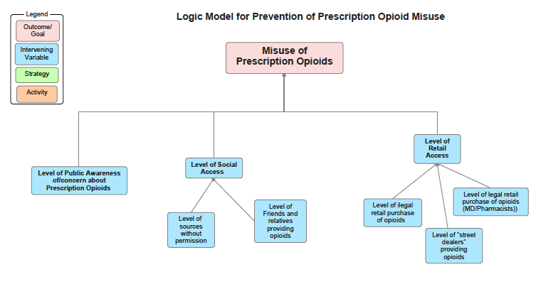

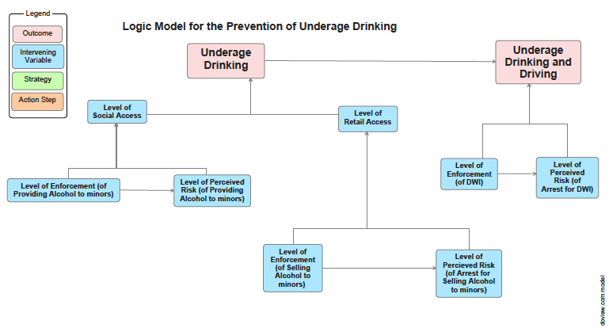
Goals & SMART Objectives

Refer to the document in your packed called “OSAP Goals and SMART Objectives”. This is your template for developing OSAP-approved goals and objectives for implementation by your prevention coalition.

GOALS
Thru the PFS15 grant, OSAP requires providers to focus on the two priorities:
- Reduce underage drinking
- Reduce Prescription Drug Misuse (particularly opioids)

These goals will require you to address more than one Intervening Variable (IV) for each and therefore, will require more than one objective. You do not need to restate the goal for each objective under the same priority (For example, underage drinking has one overarching goal but may have several objectives and strategies under it).

In addition, as new coalitions, you will be required to initially address coalition and capacity building as well as community readiness. Therefore, you will also need to write goals for these areas. These might look similar to the following:

Capacity Building goals to increase coalition capacity and community readiness:
1) Increase the capacity of the coalition to address the prevention of (underage drinking and prescription drug misuse) among youth and young adults.
2) Increase community capacity and readiness to address the prevention of (underage drinking and prescription drug misuse) among youth and young adults.

Grouping strategies to form a comprehensive strategic plan:
The best strategic plan will include strategies that are complimentary to one another. We will guide you in identifying a mix/bundle of strategies that when implemented together, will achieve the overall goal of preventing underage drinking and prescription painkiller misuse.
Examples of such bundles are:
- Perception of Risk (of legal consequences) is not a stand-alone strategy but requires implementing with an enforcement, retail, or social access strategy.
- Addressing Social Norms/Attitudes around prescription painkiller misuse requires implementing with a social access strategy(s).

OBJECTIVES
SMART Objectives will be written for strategies and based on intervening variables (IVs) you’ve identified through your assessment process.

Specific – Include your specific geographic location that you wish to affect (county, town, school, community, pueblo, etc.). Also include the projected change you wish to make. It must be measureable (increased from 1 to 2, decreased from 6% to 5%, etc.) If you choose to increase anything by a %age, you should state your baseline %age. If do not have baseline data, state that you do not have it at this time, though you will be expected to present it in your periodic reporting.

Measureable – Change in your objective must be measureable within the fiscal year. Do not propose a change that you cannot measure (i.e., if law enforcement will not provide you with enforcement data, then do not write an objective to change it because you will have no date to measure changes).

Achievable – Choose a target CF/IV that you can make changes in over time. If you want to improve parenting skills but have no wherewithal to widely implement a parenting program, it is not achievable. If you have a strong adversary in Law Enforcement or in the school system, even if that is where the needs assessment data indicate a problem, your objective may not be achievable. Does your coalition have the capacity to achieve an objective?

Realistic – You determine the amount of change your program hopes to make. Don’t over-estimate the change you want to make in 1 year; it must be realistic. Be conservative so that meeting your objectives can be celebrated.

Time limited – “…June 30, 2014” should be included in every objective propose. You have one fiscal year to achieve the objective.

For every objective you write, ask yourself and other stakeholders does it meet the SMART criteria?

Compiling the Plan

ACTIVITIES
•Each strategy will be made up of activities or benchmarks.
•Benchmarks are the details of the strategy that have to be accomplished.
•Benchmarks should not be listed as a strategy in the strategic plan.
Example:
Strategy: “Parents Who Host Lose the Most” Parental Media Campaign
Activities/Benchmarks:
• Develop/Obtain MOA with schools to gain access to parents
• Identify best markets to distribute info sheets to parents
• Develop information sheets
• Distribute to 4,000 High School Parents

PRACTICE
Activities / Benchmarks

OSAP recommendation: Think of benchmarks as what will be attainable in the next year. Make sure they are documentable, and/or countable. These will be included in your SOW, and placed in the STAR system so that you can bill against them. During periodic OSAP reporting, refer to these when you report your progress towards your objectives.

Example Strategic Plan

By utilizing these examples, participants will be able to complete a strategic plan template for one goal and objective.

Goal: | Reduce Underage Drinking in Name of Community (County/College)
Goal Indicator(s):
Intervening Variable:
Strategy (include the number corresponding with OSAP list): | OSAP Strategy #
Objective:
Objective Indicator(s):
Activities/Benchmarks: | - Enter activity for this objective in the BHSD STAR prevention data management and billing database.
Justification for Strategy Selection:

STRATEGY SELECTION
Program, Practices, and Policies
- Program: Individually focused strategies designed to change individual attributes such as knowledge, skills, abilities, beliefs, and attitudes.
- Policies: Aimed at changing conditions in the larger environment. Rules, regulations,
or laws designed to prevent substance abuse.
- Practices: Standard activities that are based on policy or used to support the
implementation of policy.

1. Identify community-specific factor/intervening variable to be addressed
2. Perform a research or literature review on evidence-based practices, policies, or programs that have been successfully used to address contributing factor (this has been done for you already by OSAP)
3. Consider cultural appropriateness and sustainability of outcomes of strategy
4. Ensure there is a logical connection between selected strategy and contributing factor
5. Identify benchmarks needed to successfully implement strategy. (Along with Objectives and Indicators, Benchmarks will also become part of your OSAP Scope of Work, and loaded into the STAR system for monthly fiscal reporting)

OSAP Requirements | OSAP requires PFS15 Grantees to identify a comprehensive strategic plan to prevent Prescription Drug Misuse and Underage Drinking. The plan will include:  - six environmental strategies, and  - two capacity/coalition buidling strategies.

New Mexico Office of Substance Abuse and Prevention
Strategic Planning Template

Please submit this report to the following people Karen Cheman, Karen.Cheman@state.nm.us, Heather Stanton, Heather.Stanton@state.nm.us, Antonette Jose-Silva, antonette.jose@state.nm.us, Tina Ruiz, ruiztinam@gmail.com, Liz Lilliott, lilliott@pire.org, and Martha Waller Mwaller@pire.org

Coalition Name:

Project Director:
Program Coordinator:
Other Staff:
Report Completed by:
Date Completed:

Briefly describe your coalition
Key Members:
Core Team Members:
Key accomplishments to date (highlights):
Challenges or barriers experienced:

An Overview of [Name of Community (County/College) and its Coalition]

Our Community [Enter a general picture of the community including information about its population (age, race, gender, tribes, etc.), its geography including a map, its uniqueness, and challenges encountered, etc. You might enter tables from various sources online such as: https://gonm.biz/site-selection/county-profiles/]

Formation and Purpose [Describe the process used to form the coalition, purpose of coalition, date of formation, and frequency of meeting. Include the overall purpose and role of the coalition, resources available, and any other relevant information regarding its purpose.]

Coalition Membership [List the names of members, the community sector they represent, and the process by which your membership was recruited.]

Coalition Vision and Mission Statements [Describe the process by which the vision and mission statements were developed, how decisions were made regarding its development, and it’s date of formation. Include the verbatim vision and mission statements, along with descriptions of the purpose of specific objectives.]

Strategic Planning Process [Describe the process you went through with your community coalition members, and the steps you will take after this training to complete your strategic plan.]

Logic Model for the Prevention of Underage Drinking

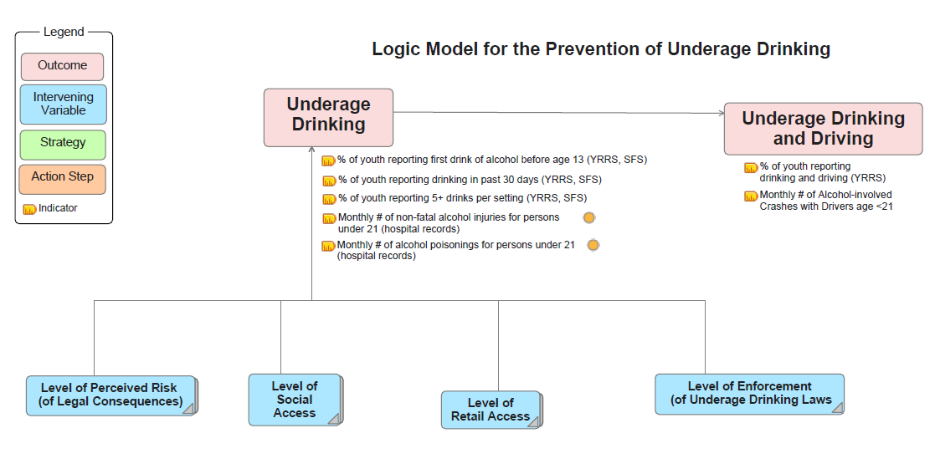
Prevention of Underage Drinking
(copy and paste these items for each strategy selected for this goal area)

Goal: | Reduce Underage Drinking in Name of Community (County/College)
Goal Indicator(s):
Intervening Variable:
Strategy (include the number corresponding with OSAP list): | OSAP Strategy #
Objective:
Objective Indicator(s):
Activities/Benchmarks: | - Enter activity for this objective in the BHSD STAR prevention data management and billing database.
Justification for Strategy Selection:

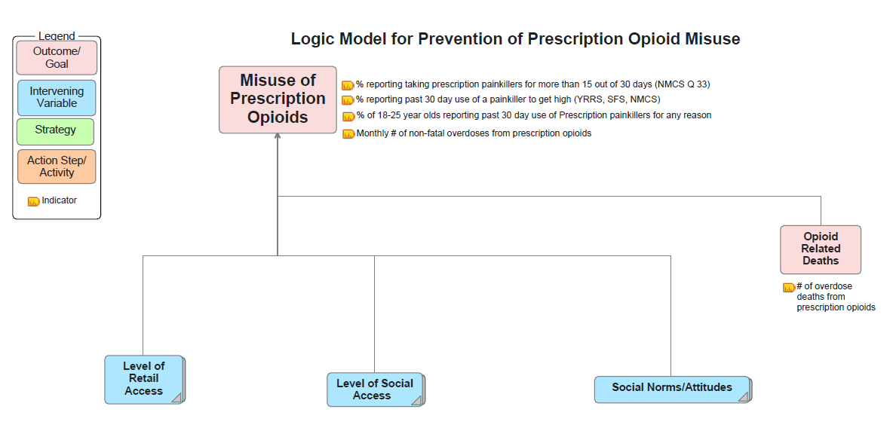
Logic Model for the Prevention Prescription Painkiller Misuse

Prevention of Prescription Painkiller Misuse
(copy and paste these items for each strategy selected for this goal area)

Goal: | Reduce Prescription Painkiller Misuse in Name of Community (County/College)
Goal Indicator(s):
Intervening Variable:
Strategy (include the number corresponding with OSAP list): | OSAP Strategy #
Objective:
Objective Indicator(s):
Activities/Benchmarks:
Justification for Strategy Selection:

Coalition Development Strategy

Goal: | Increase the capacity of the coalition to address the prevention of underage drinking and prescription painkiller misuse among youth and young adults in Name of Community (County/College)
Goal Indicator(s):
Intervening Variable:
Strategy (include the number corresponding with OSAP list): | OSAP Strategy #
Objective:
Objective Indicator(s):
Activities/Benchmarks:
Justification for Strategy Selection:

Capacity & Readiness Strategy

Goal: | Increase community readiness to address the prevention of underage drinking and prescription painkiller misuse among youth and young adults in Name of Community (County/College)
Goal Indicator(s):
Intervening Variable:
Strategy (include the number corresponding with OSAP list): | OSAP Strategy #
Objective:
Objective Indicator(s):
Activities/Benchmarks:
Justification for Strategy Selection:

OSAP FY 2018 INTERVENING VARIABLES & APPROVED STRATEGIES TO ADDRESS ADULT AND YOUTH DWI AND BINGE DRINKING
A1. Low Enforcement of ATOD Laws
- Promotion & coordination of stronger enforcement of all existing youth and adult alcohol & drug related laws (citations and arrests for: minors in possession, sales to minors, providing alcohol to a minor, Social Host Ordinance violations; DWIs, sales to intoxicated, server liability)
- Promotion & coordination in order to increase enforcement efforts/activities: sobriety checkpoints, saturation patrols, party and SHO patrols & SIU activity (compliance checks, shoulder taps, sales to intox checks).
- REQUIRED FOR ALL PROGRAMS: Develop and strengthen enforcement of ATOD policies at schools (includes the elimination of zero-tolerance policies that lead to suspension and expulsion from school) Also applies to reducing prescription drug abuse.
A2. Low Perceived Risk of Arrest/ Legal Consequence
  - Publicizing enforcement efforts and activities (party patrols, SHO patrols, sobriety checkpoints, saturation patrols, SID activities, etc.)
A3. Retail Access
a. Responsible Beverage Service Model (a package including alcohol merchant education, store manager policies, age verification, server training)
b. Restrictions on alcohol placement in stores
c. Restrictions on alcohol advertising by schools, day care centers, etc.
d. Restrictions on alcohol sales (days, hours)
g. Restrictions on local alcohol discounts and sales
A4. Social Access (for youth only)
- Developing and coordinating a Parent Party Patrol
- Parents Who Host Lose the Most
- Media to increase awareness of 4th degree felony and Social Host Laws

OSAP FY 2018 INTERVENING VARIABLES & APPROVED STRATEGIES TO ADDRESS PRESCRIPTION PAINKILLER MISUSE AND ABUSE

- Retail Access
- Increase timely use of the PDMP by medical providers to record prescriptions and identify potential abusers, e.g., user education.
- Increase timely use of the PDMP by pharmacists to identify potential abusers.

- Social Access
a: Target parents to restrict youth social access to prescription pain-killers with by working directly with PTAs or similar parent groups to encourage locking up meds, proper disposal, use of lock boxes, and to share information with parents on adolescent prescription drug misuse and abuse, as well as dangers of sharing.
b: Target parents to restrict youth social access to prescription pain-killers by developing a culturally appropriate “parent handbook” that includes a medicine cabinet inventory, info handouts, federal guidelines on proper disposal of prescription drugs, & YRRS results related to prescription drug non-medical use
c: Target parents to restrict youth social access to prescription pain-killers by creating tools and promoting and implementing policies that insure that SBHCs & prescribers share information with parents on adolescent prescription drug misuse and abuse, proper storage & disposal, and dangers of sharing.
d: Restrict social access through the elderly (locking up meds, provide lock boxes, not sharing meds, etc.) with strategies that educate on proper storage, disposing, and sharing of medications and respond to local social norms and conditions.
e: Work with pharmacies to always share information with customers about the dangers of abuse, proper storage & disposal, and dangers of sharing of prescription opioids and other potentially abused drugs.
f: Work with pharmacies to provide or sell lock boxes to customers (e.g., providing them to new customers or those who switch medications to them) and offer onsite drop-boxes or other opportunities for safe continuous medications return.
g: Work directly with medical providers to create and implement policies such that medical providers educate patients on proper storage of meds and encourage the use of lock boxes.
h: Work directly with medical providers so they can directly educate or encourage patients to reduce social access: develop and disseminate among providers a “provider guide” that could include medicine cabinet inventory, model policies for offices, info handouts, federal guidelines on proper disposal of prescription drugs, & YRRS results related to prescription drug non-medical use, ways to bring the topic up for discussion with patients & parents.

- Social Norms/Attitudes
Use media resources to increase awareness of prescription painkiller harm & potential for addiction, and to increase awareness of dangers of sharing, how to store and dispose of prescription drugs safely. (Can include creating media around prescription drug “Take Back” events regarding safe storage and disposal or use of local drop/lock-boxes)

CAPACITY STRATEGIES
C1. Strategies to enhance coalition structure (from sections A & B on the coalition checklist) Include all or most of the bullets below in your SOW:
- Clarify vision, mission and goals of (coalition) with coalition members and by documenting and sharing a synopsis with all coalition members at the beginning of each meeting.
- Strengthen (coalition) structure and membership by defining members’ roles and responsibilities.
- Build (coalition) capacity by improving the structure and organization of our meetings.
- Build (coalition) capacity by identifying subcommittees to address important tasks based on members’ skills.

C2. Strategies to enhance coalition growth and leadership (from sections C & F on the coalition checklist) Include all or most of the bullets below in your SOW:
- Strengthen (coalition) leadership by having two leading members attend leadership training, practice relationship building and gaining stakeholder buy-in, and assessing progress toward goals.
- Coalition members provide orientation and mentoring to new recruits/members
- Different coalition members are given opportunities to take the lead on coalition components/work

C3. Strategies to enhance outreach and communications (from sections D & E on the coalition checklist) Include all or most of the bullets below in your SOW:
- Build (coalition) capacity by increasing outreach and communications between members, key stakeholders, and specific groups, through sharing of activities and seeking feedback from community residents.
- Development and dissemination of newsletters, website updates, social media promotion, and work with local media groups to promote coalition efforts.
- Regular communication is maintained with coalition members and regular meetings are held.

C4. Strategies to enhance relationships with local government and other community leaders (from section H on the coalition checklist) Include all or most of the bullets below in your SOW:
- Build (coalition) capacity by recruiting new and improving relationships with local officials and community leaders.
- Develop a method to keep elected officials/community leaders informed about pressing issues, needs, and outcomes.
- Assign coalition members to attend important community meetings and events

C5. Strategies to enhance data driven planning and environmental change (from sections G, I & J on the coalition checklist) Include all or most of the bullets below in your SOW:
- Build (coalition) capacity by learning to collect, analyze and use data in our prevention planning.
- Review progress on the strategic plan/coalition efforts with the coalition and record feedback on progress and accomplishments.
- Brainstorm ideas for improving integration with local resources and take appropriate actions
- Build (coalition) capacity by educating all members on the use and value of environmental prevention strategies.

C6. Strategies to enhance cultural competency (from section K on the coalition checklist). Include all or most of the bullets below in your SOW:
- Build (coalition) capacity by recruiting/maintaining members that reflect the diverse cultural and economic makeup of our community
- Subcommittee/task force reviews activities and products for cultural appropriateness prior to dissemination/implementation
- Provide translation of materials and interpretation into languages other than English spoken in your population.
- Disparities, racism, and poverty are included in coalition discussions, planning and goals
- Work to address possible and unintentional barriers to diverse community participation and representation in coalition.

C7. Strategies to enhance funding and sustainability (from section L on the coalition checklist). Include all or most of the bullets below in your SOW:
- Build (coalition) capacity by identifying and applying for funding from additional sources to support prevention efforts.
- Develop plan and identify researchers/writers for specific grants or funding opportunities
- Develop/review a sustainability plan that addresses organizational and programmatic sustainability and program effectiveness.

COMMUNITY READINESS BUILDING STRATEGIES

D1. Strategies to increase community awareness. Include all or most of the bullets below in your SOW:
- Increase awareness of community prevention efforts, who programs serve, gaps in prevention services, the longevity of efforts, etc.
Develop a plan / action steps for informing the community about prevention efforts (convening community meetings, etc.)
- Assess and address the strengths and weaknesses of current efforts
- Identify formal and informal policies, practices or laws related to these issues

D2. Strategies to increase readiness among community leaders. Include all or most of the bullets below in your SOW:
- Identify what leaders are critical to the issue(s) at hand and/or experts that could help your efforts
- Increase the level of knowledge/concern/buy –in from community leaders (specify people/positions) for prevention efforts
- Involve community leaders in prevention efforts

D3. Strategies to improve community climate toward prevention. Include all or most of the bullets below in your SOW:
- Identify and resolve obstacles to substance abuse prevention (under what circumstances is it acceptable? What unique factors in our community make planning and implementation difficult? Etc.)
- Increase support for substance abuse prevention efforts by gathering and disseminating data on the nature of the problem, use assessment data to plan prevention programs and policies, collaborate with agencies working on other prevention issues (HIV, delinquency, etc.), leveraging resources, and sharing successes/outcomes.

D4. Strategies to increase knowledge of the issues. Include all or most of the bullets below in your SOW:
- Develop and disseminate information / conversations about the dynamics of substance abuse in the community, data related to priority issues, and current and planned efforts to address the issues. Materials and methods will need to be adapted according to the selected/identified group or population.
- Develop and disseminate information / conversations about preventing access to substance in the home and community. Materials and methods will need to be adapted according to the selected/identified group or population.
- Develop and disseminate information about prevention and its importance to the community, including information on the IOM Continuum of Care and why prevention is as important as treatment in improving community health.

D5. Strategies to increase resources to prevention. Include all or most of the bullets below in your SOW:
- Identify available resources for substance abuse prevention (personnel, financial, organizational, etc.)
- Increase the level of prevention funding by identifying and applying for funding from additional sources to support prevention efforts.
- Increase the number of agencies/partners involved in prevention efforts

RESOURCES

New Mexico Laws at a Glance
http://www.cdc.gov/homeandrecreationalsafety/Poisoning/laws/state/nm.html

Laws Requiring a Physical Examination before Prescribing
Laws that require a physical exam of a patient by a health care provider prior to prescribing may be intended, in part, to prevent inappropriate prescribing of controlled substances. A law was included in this resource if it requires either examining the patient or obtaining a patient history and performing a patient evaluation prior to prescribing a controlled substance or if it requires a bona fide patient-physician relationship that is elsewhere defined in statute or regulation to include a physician examination. New Mexico requires a physical exam before being issued a prescription for pain management or for controlled substances and the Pharmacist may not dispense if reason to believe there is no practitioner-patient relationship.
Laws Requiring Patient Identification before Dispensing
Laws that require patients to provide identification prior to filling a controlled substance are designed to prevent prescription fraud and diversion by ensuring persons obtaining a prescription are who they claim to be. CDC included a law in this resource if it requires a person to identify himself or herself or requires or permits a pharmacist to request identification prior to dispensing a controlled substance. This might occur at the discretion of the pharmacist or in certain circumstances, e.g., the person has similar prescriptions from multiple practitioners or the prescription was written in another state, or the prescription was not covered at least in part by a health plan.

Among the laws requiring identification prior to dispensing, CDC identified a subset requiring that a pharmacy submit a patient’s “identification number” to the state prescription drug monitoring program. “Identification number” is defined as the unique number contained in the state-issued valid driver’s license of the recipient and/or the person for whom the drug is intended, a valid military identification card, a valid identification card issued by the bureau of motor vehicles, or an assigned unique identification number that could be linked to other personal identifiers. New Mexico requires a government issued photo ID to be shown before picking up Rx pain killers.

Laws Providing Immunity from Prosecution/Mitigation at Sentencing for Individuals Seeking Assistance During an Overdose
A law enacted to encourage emergency treatment of people experiencing drug overdoses was included in this resource if the law provides any degree of immunity to an individual seeking help for himself or for another person experiencing an overdose. The protection could be from prosecution for possession of a controlled substance during the overdose incident or for other criminal charges. The law was also included if it makes seeking help in an overdose a mitigating factor at sentencing. Such laws are often referred to as “Good Samaritan” laws. New Mexico’s law states that a person seeking help for another person experiencing an overdose will not be charged or prosecuted for possession resulting from evidence gained from the call for help, Person experiencing overdose and needing medical attention will not be prosecuted for possession resulting from evidence gained from the call for help, and Seeking help may be mitigating factor in Controlled Substance Act prosecution.

Citations for New Mexico’s Prescription Drug Laws
Category | Legal Citation
Physical Examination/ Patient-Physician Relationship | N.M. Stat. § 26-1-16
 | N.M. Code R. § 16.10.8
 | N.M. Code R. § 16.12.9
 | N.M. Code R. § 16.10.14
ID Requirement | N.M. Code R. § 16.19.20
Immunity/Mitigation at Sentencing | N.M. Stat. § 30-31-27.1
Note: All laws enacted as of August 31, 2010.

NEW MEXICO PRESCRIPTION MONITORING PROGRAM
Web: https://pmp-web.rld.state.nm.us/ Email: NM.PMP@state.nm.us Revised 04/17/2013

BACKGROUND
The New Mexico Prescription Monitoring Program (PMP) provides information regarding the
prescription of controlled substances in order to prevent the improper or illegal use of the
controlled substance, and is not intended to infringe on the legitimate prescribing of a
controlled substance by a prescribing practitioner acting in good faith and in the course of
professional practice.

REPORTING REQUIREMENTS AND SCHEDULES
In accordance with 16.19.29.8, each dispenser shall submit the information in accordance with
transmission methods and frequency established by the board; but shall report at least every 7
(seven) days. (Dispensers may also report more frequently than outlined above. Any dispenser
who chooses to may submit on a daily basis.)
If a New Mexico licensed practitioner routinely dispenses more than 12 dosage units of a
Schedule II-V controlled substance to an individual patient within a 72 hour period, they must
report this data to the NM PMP as described above.

CADCA Prescription Drug Abuse Prevention TOOLKIT:
http://www.cadca.org/resources/detail/rx-abuse-prevention-toolkit

CDC Prescription Pain Killer Abuse, Vital Signs: http://www.cdc.gov/vitalsigns/PainkillerOverdoses/index.html

Alcohol: No Ordinary Commodity (preview full article):
http://onlinelibrary.wiley.com/doi/10.1111/j.1360-0443.2010.02945.x/full

CDC Community Guide: Preventing Excessive Alcohol Abuse: http://www.thecommunityguide.org/alcohol/index.html

APPENDIX
Prioritization Example
- First Column: Record the risk factors your data revealed for each community issue
- Second Column: Determine what the severity level is for each contributing factor based on the data you have gathered throughout the assessment phase. Low-Medium-High
- Third Column: Determine what level of capacity exists for each contributing factor. Think about resources, people, partners, etc.
- Fourth Column: Determine what level of readiness your community has to address each contributing factor. Think about your community’s ability to begin working on each factor.
- Last Column: Consider the ratings each area was given (severity, capacity & readiness) to determine the overall priority level.
- Please rank each contributing factor

The Problem: Alcohol-Related Motor Vehicle Crashes
LOW ENFORCEMENT
Contributing Factors | Severity | Capacity | Community Readiness | Prioritization  Level
Lack of funds to pay overtime | Very High | Low – Additional funding has been difficult to obtain, increased checkpoints cannot occur without this funding | Stage 6 - Data justifies need but efforts to overcome shortage have not begun | 3rd
Low number of officers | High | Medium - coordination between jurisdictions is minimal but some progress has been made | Stage 6 - Planning has begun and the pros & cons of cross training officers and coordinating checkpoints is being addressed | 2nd
Enforcement has other priorities | Very High | Medium/High - A few key leaders are addressing the need for increased DWI enforcement, strategic planning session is planned, some opposition does exist | Stage 7 – Efforts have begun to re-examine priorities and public input also reflects support for increased enforcement | 1st

RETAIL ACCESS
High number of retailers sell to minors | High | High – Several owners/retailers are on board, standardized server training has begun | Stage 7 – Planned efforts are underway and supported by community | 1st
Failure to check IDs properly | High | Medium – Suggestions to purchase automated ID readers have been rejected but owners/managers are supportive of including this specific issue in future trainings | Stage 7 - Retailers have agreed to financially support trainings, modifications to the curriculum have been made to include checking ID’s properly | 2nd

Acknowledgements
This training manual and the tools associated with it were developed by contractors of the New Mexico Office of Substance Abuse Prevention, under its direction and guidance: Coop Consulting, Inc. adapted and prepared this manual and developed some of its content; Elizabeth Lilliott and Martha Waller of PIRE, and Paula Feathers of Kamama Consulting, also made significant contributions to materials included in this manual. Material pertaining to the development of logic models, data collection, and data management were provided to New Mexico through a technical assistance initiative of JBS as a SAMHSA/CSAP contractor, and its contracted experts Rebecca Carina and Harold Holder, Ph.D. The materials have been altered and adapted from trainings originally developed with SAMHSA Strategic Prevention Framework State Incentive Grant funds, and Partnerships for Success II funds.
For questions regarding the information in this training, please contact:
- Karen Cheman (Office of Substance Abuse Prevention) Karen.cheman@state.nm.us
- Tina Ruiz (Coop Consulting) ruiztinam@gmail.com
- Elizabeth Lilliott (PIRE) Lilliott@pire.org

Strategies approved only for youth are in blue font. Black font can apply to adults as well as youth, depending upon the particular approach.
Please note that numbering/lettering is purposeful due to billing and contracting requirements. Please follow this numbering system for strategies.

